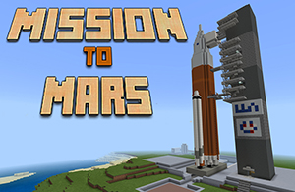 **Name:**  
Before you launch for Mars, you must do some research to plan your trip and decide what to take with you. Please write your entries in a different colour to the questions and prompts!

Edit the footer – add your name

**SECTION 1 – To be completed before you launch!**

**1) Research how to survive on mars**.

What is the climate like on Mars?

What dangers will the first astronauts face?

What items/supplies will you need to bring with you for your immediate survival, when you first land on Mars? Make a list and give reasons for your choices.

**2) Research how to build a base on mars.**

What important structures and rooms will be needed?

What is an airlock entry?

How could you protect against radiation?

Make a list of what you will need to bring to help build a dwelling / base.

**3) Research how to build a SUSTAINABLE Colony on Mars.**

What does sustainable mean?

What resources are already available on Mars?

What items/supplies will you need? Think about setting up a greenhouse to grow crops, mining to get ores, melting ice for water, brewing stand for potions.

Make a list of what you will need for farming

You now need to decide what your FINAL 27 items will be. You will start on Earth in **creative mode** and have access to the full inventory of Minecraft. There is room on the ship for ONE CHEST of supplies. You must choose what to bring and add it to the **Yellow Chest** in the Cargo Bay before launch. Once you reach Mars you will be in **survival mode** and will ***get hungry fast*** while you explore the new world and build your new home! (Be sure to bring plenty of food, 32 beef per person recommended)

You **MUST NOT**, at any stage, change any of the Game settings. If you do this will affect the grade you receive!

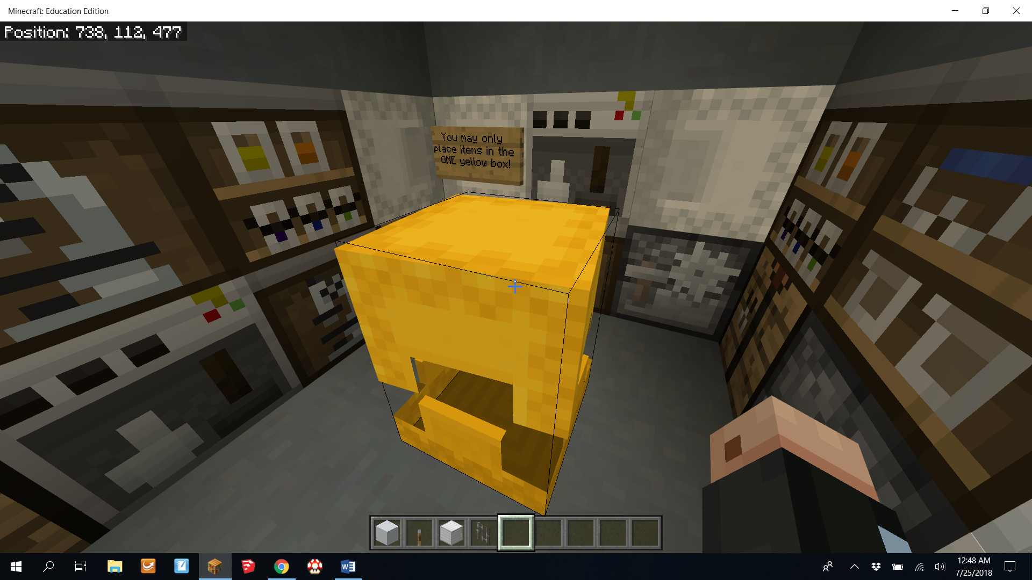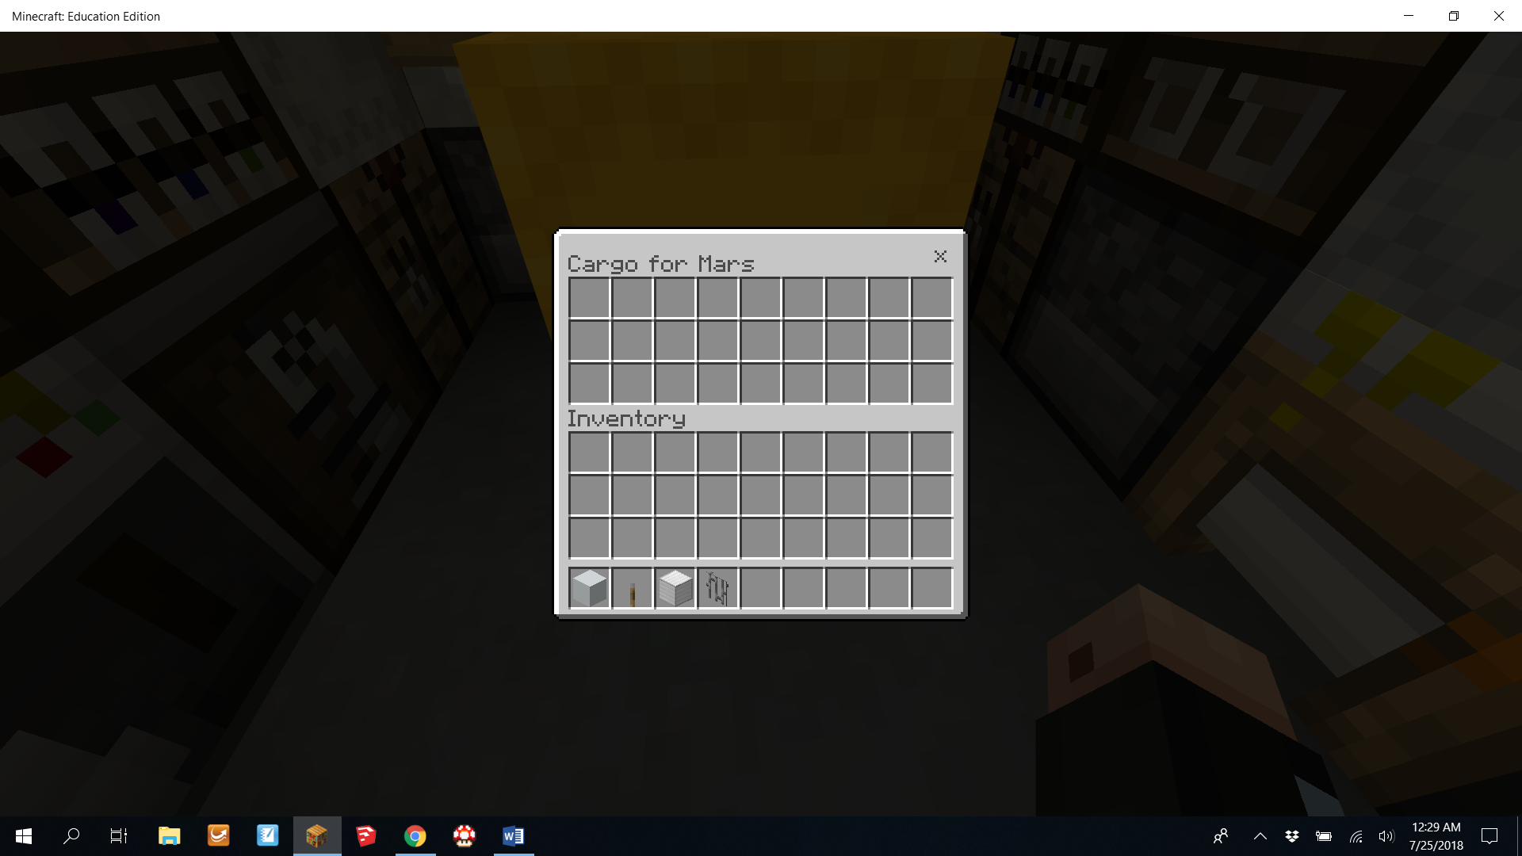

List the 27 Items you will take with you.

**SECTION 2 – To be completed when you have landed on Mars!**

**Tasks to complete on Mars:**

1. Build a living space! Should include beds, eating/meal preparation areas…
2. Build a greenhouse to grow crops (will need to bring lots of dirt blocks!)
3. Should have double door air lock entry, radiation shielding of some sort …
4. Build a science lab / medical room…
5. Start searching for resources? Ice blocks, sand/clay to use for building structures, ores deeper underground…

You **MUST NOT**, at any stage, change any of the Game settings. If you do this will affect the grade you receive!

Space Journal Entries

***Note:*** *Each ‘Day’ of the expedition you need to write a journal entry. The entry should include supportive images that you have either screen captured or photographed in the ‘world’ using the camera tool. You must discuss things you have tried to do e.g. get into the Cargo Bay and retrieve the contents of your Yellow Chest. You MUST write about problems you came across and how you solved them (or didn’t). Your journal is worth a significant amount of your assessment.*

Day 1 – Date

Day 2 – Date

Day 3 – Date etc. etc.